**MESD LMS Documentation – Produce and view students’ progress reports**

To facilitate with producing and viewing students’ progress reports.

**Background**

This module handles requests directly from educators to produce and view students’ progress reports.

**Usage**

**Producing progress reports**

1. Login as an Educator.
2. Go to *‘My courses’*, select the course for which you want to produce progress reports.
3. Make sure that you have set up grade items (e.g. assignments, quizzes etc.)
4. Go to *‘Grades’* to view overall grades for each students on each assignments and quizzes.

**View progress reports**

1. While under the selected course, go to *‘Reports’.*
2. Select the activity you would like to view.

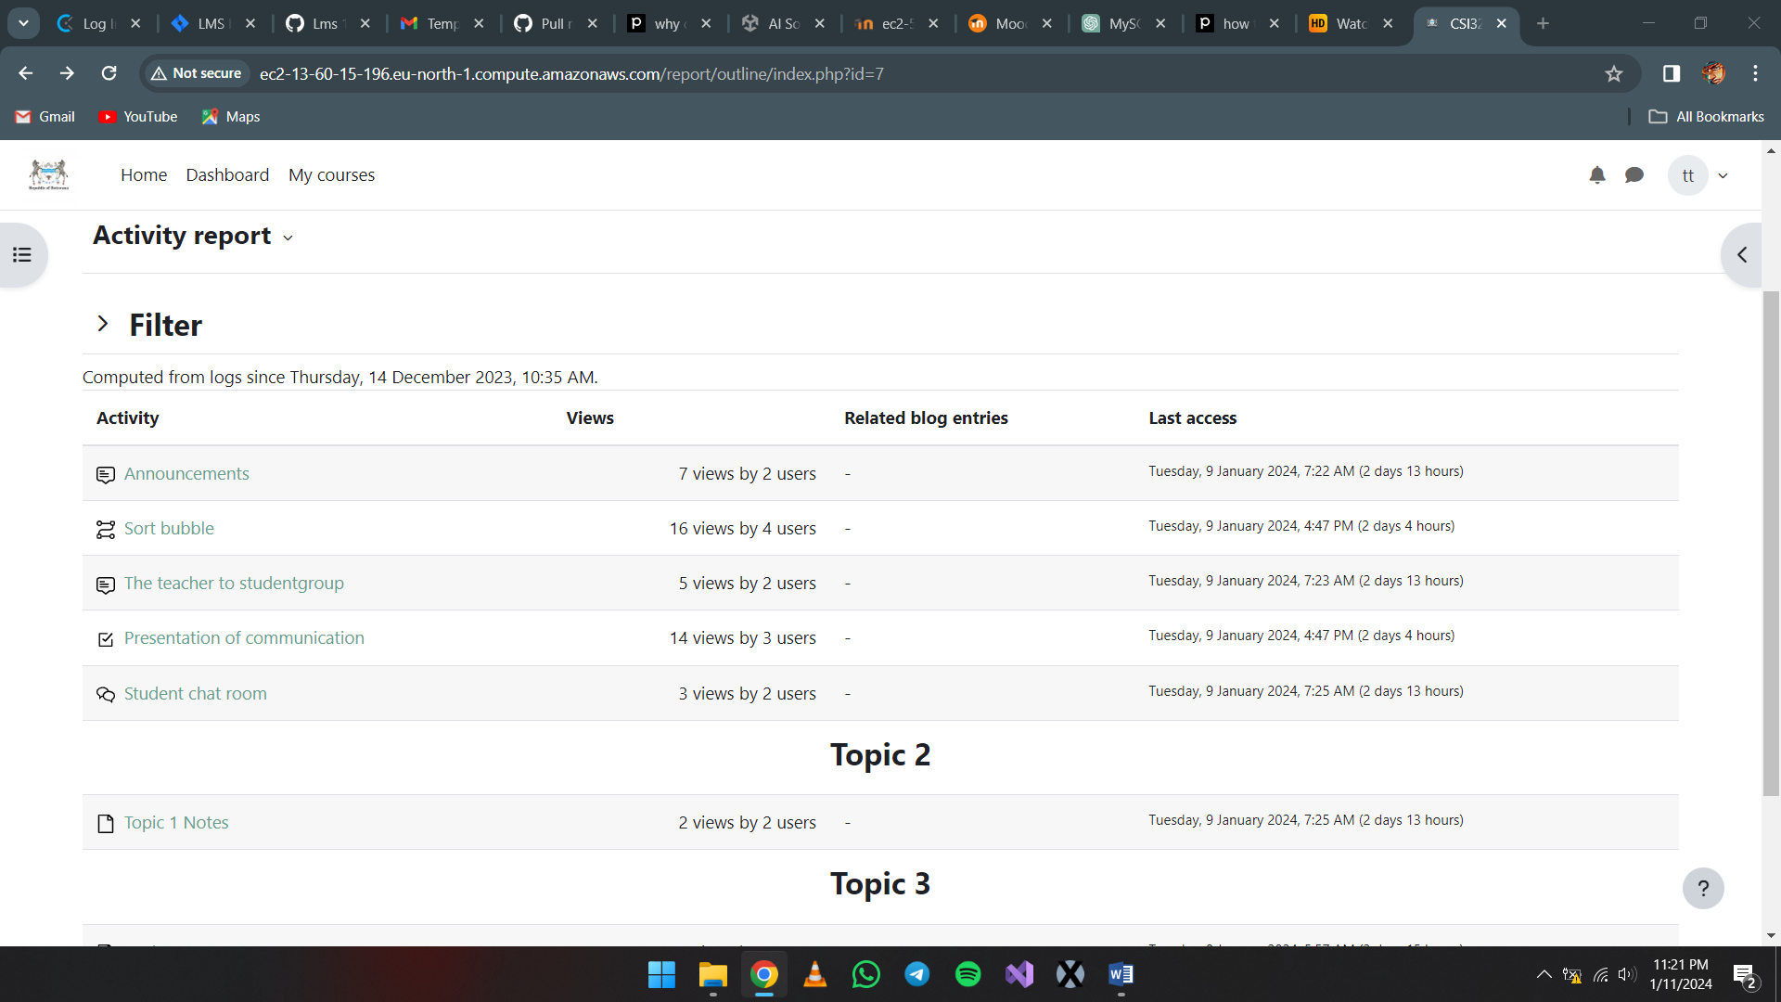

1. Select *‘Results’*.

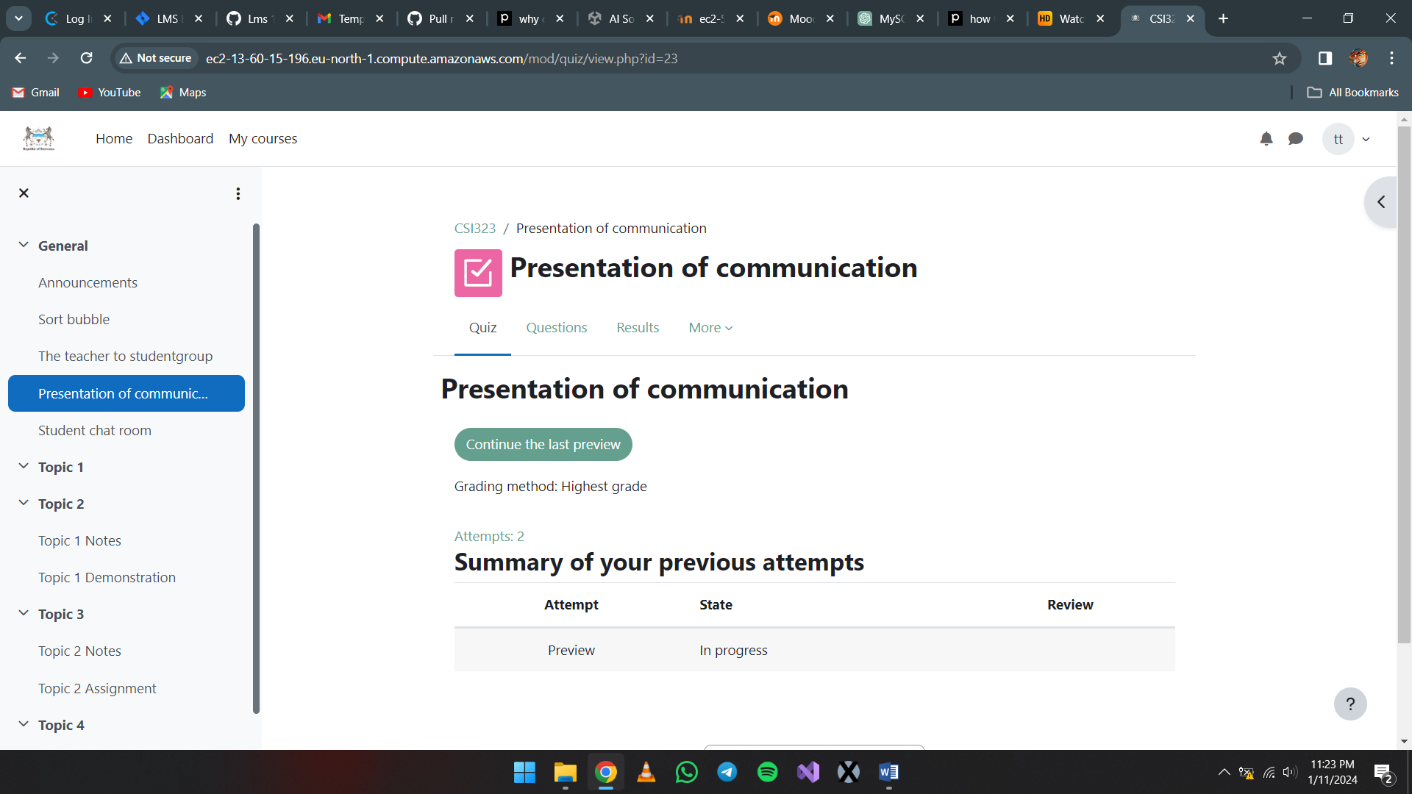

1. From here you will be able to view the grades of every learner under that assignment or quiz, view graphs, filter learners, show what to include in report and display options.